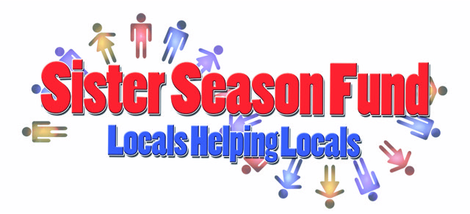
2020 important dated & event list
Board meetings, January 6th, Feb 3rd, March 7th, April 4th. May 2nd, June 6th, July 11th, August 1st, Sept 5th, Oct 3rd , Nov 7th, Dec 5th
Bingo, 1st quarter: Jan 13th, Feb 10th, March 9th, April 13th, May 11th, June 8th,

Events
- Chili cookoff, January 25th
- Mardi Gras King, Feb 22nd
- Mardi Gras Pub Crawl, Feb 25th
- Golf Tournament date TBD
- Bed Races, April 25th
- Survivors Party Memorial Day, May 25th
- Anniversary Party Aug 15th
- Musicians Festival Sept.?
- Thanksgiving Turnabout, Nov 26th

