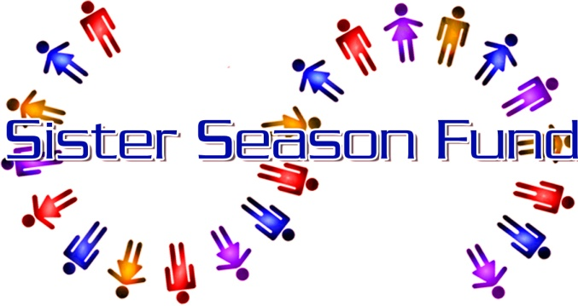
A FLORIDA NOT FOR PROFIT CORPORATION 501 (C) (3) CHARITY
Tax Id # 20-3179971

Dear Proprietor:

Please join in support of the Conch Republic Days 2020 Bed Races on Saturday, April 25th.

Sister Season Fund, Inc. (SSF) is reviving the bed race event as a part of the Conch Republic Celebration week. We are seeking sponsors and bed race teams for what I sure to be one of the most hilarious events during the week-long celebration. As a local business, you can help by becoming Sponsor.

There are three Sponsorships to choose from. You can be a Participating Sponsor, which includes entering a bed race team; an Advertising Sponsor which does not enter a team; or a Participating/Advertising Sponsor which receives the benefits of the Advertising Package AND enters a bed race team. See the Sponsorship Donor Form attached for details.

Sister Season Fund started in September 2005 in response to a need among those working in the tourist industry in Key West. As most are without health insurance and financial reserves, when one becomes ill or injured, through no fault of their own, they become in danger of losing their home. Sister Season Fund can assist with rent and utilities. Since Sept 2005, we have given over $700,000 in assistance.

Thank you in advance for any help you can give. Sister Season Fund is all about “Locals Helping Locals” and hope that you will join us in that effort. Should you have any questions, please call me at 305-304-9828 or email me at ahnajulie@gmail.com.

Sincerely,

Julie Hanson, President
Sister Season Fund, Inc.

422 Fleming St./P.O. Box 4535, Key West FL 33040
www.sisterseason.com, sisterseason@aol.com

