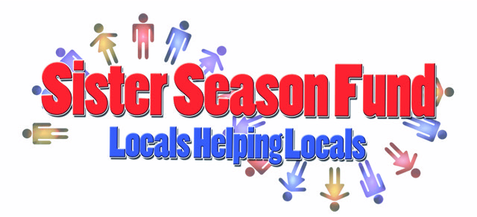

Conch Republic Days 2020
Bed Race Rules & Regulations

- Each team must have six (6) persons to a team, 4 pushers, 1 rider, 1 captain/ alternate.
- Two beds will race at a time for a timed trial. Teams will compete in Double Elimination Races.
- All beds must be decorated (keep in mind there is a contest for best decorated bed)
- All decorative elements to your bed must be securely attached and pose no risk to the rider, pushers or other teams. No sharp objects or projections. Race coordinators may remove any element prior to the race if necessary.
- Team name, company name or organization name must be displayed on the bed and securely fastened.
- Any size wheels are permitted.
- No breaking devices allowed.
- Steering devices allowed.
- Beds cannot be bigger than 6’X8’.
- All beds must have a mattress.
- All beds must pass a tech inspection prior to each race. Staff decision prevails
- Bed riders should wear a helmet (bicycle or football helmet) own safety and must sit or lie flat on the bed. Absolutely no standing or kneeling.
- Bed Riders cannot aid in propulsion.
- Pushing the bed only during the race, no pulling.
- All 5 team members must pass finish line (with the bed) in order to win.
- No person may be a member of more than one team.
- Appropriate clothing, shoe wear and safety headgear are the responsibility of each team member.
- All pushers must be in control of the bed at all times.
- Nothing is allowed to be thrown or tossed from the bed while racing .
- All pushers and riders must remain in contact with the bed at all times and be in control of the bed until it comes to a complete stop.
- Absolutely no alcoholic beverages allowed.
- Team members may not interfere with opponents in any way during the race. Teams must stay in their lane for the entire race and may not cross the center line. Any cross over to opponent’s lane will cost that team three (3) seconds.
- Damage incurred or caused will be the sole responsibility of involved team and not Sister Season Fund, Inc. or its affiliates.

NOTE: Remember, accidents do happen and can include falling down on the pavement, scrapes, bruises, tripping, etc. Safety gear for all participants to avoid such hazards is recommended. Everyone’s safety is a priority.

