SCHEDULED EVENTS
Sept 17 & 18th - Music Festival @ Smokin Tuna, Ginger, coordinator
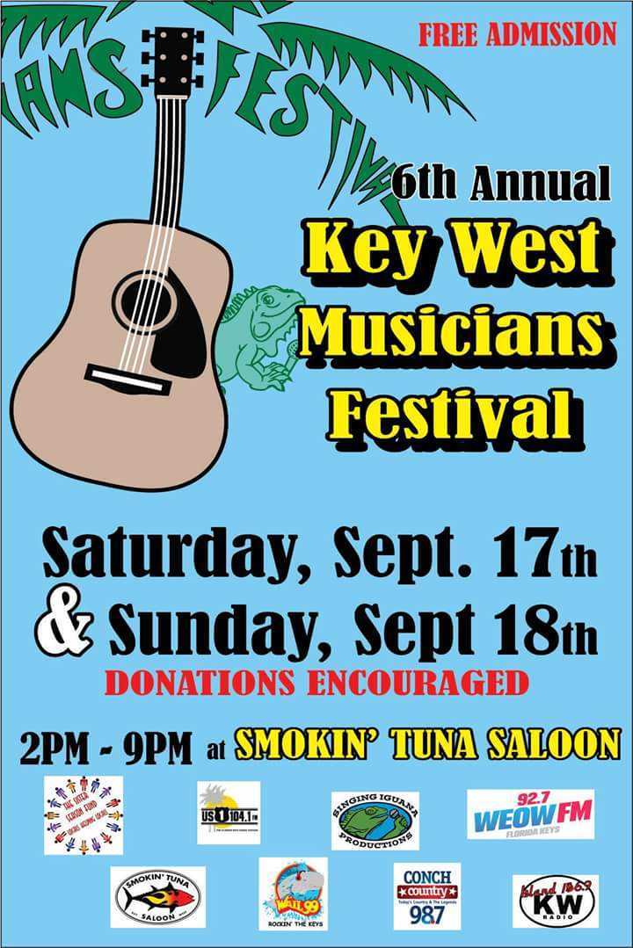

October 1st The Marker Pin Up contest, 5:30 - ?
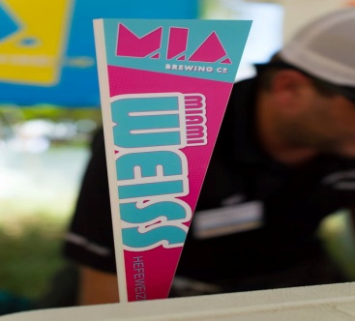
October 8th Brunch at Bagetelle Update to follow
October 19th Mangia Mangia hosting and donating 20% of total sales for the evening, dine in or take out 5:30-9:30
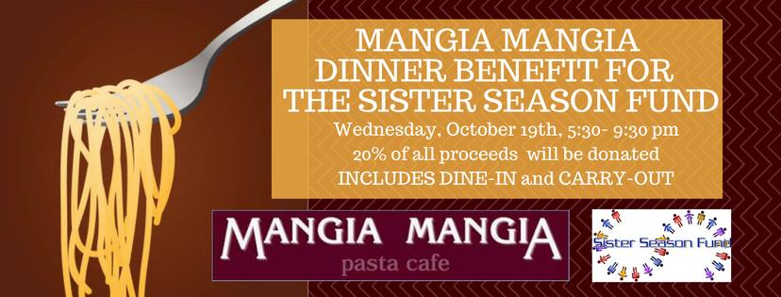

November 24th – Thanskgiving “Turkey Turnabout”,@ BSP, Julie, coordinator
December 10th Roller Derby , (portion of ticket sales to be donated to us): Megan Faust
Feb ? Mardi Gras Pub Crawl
March ? , Fashion Show, Julie, coordinator
May 29th Survivors Party, coordinator
August 4th Anniversary Party @ Bottle Cap

