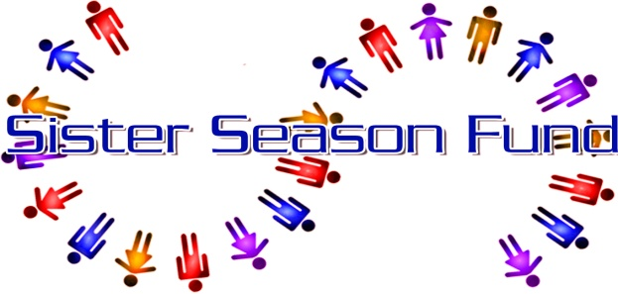

A FLORIDA NOT FOR PROFIT CORPORATION A 501 (C)(3) CHARITY
Tax ID # 20-3179971

Sponsorship/Donation Form

Date: April 29th Conch Republic Days 2023 Bed Races

Donor Name: _____________________________________

Contact Name: ____________________________________

Address: _________________________________________

Team Registration:
$200 Bed only
Entry fee

Sponsorship Packages:
$500 Participating Sponsorship
Bed entry
Logo on our SSF Event Banner
SSF Social Media

$500 Advertising Sponsorship
Your own 6ft Banner placed along the racetrack
SSF Social Media

$600 Participating/Advertising Sponsorship
Bed entry
Logo on our SSF Event Banner
SSF Social Media
Your own 6ft Banner along the racetrack

Contact info: Sister Season Fund Inc.
422 Fleming St
P.O. Box 4535
Key West, Fl 33040
FB: Sisterseason Inc.
Email info@sisterseason.com

Julie Hanson: 305-304-9828

